Dear Parent/Guardian,

I am writing to inform you that this term, as part of a unit of learning as outlined by the Australian Curriculum, we will be discussing online safety.
We are excited to cover this topic using new resources developed by the Australian Federal Police’s ThinkUKnow program and the Australian Centre to Counter Child Exploitation (ACCCE).
During class we will be reading the children’s picture book Jack Changes the Game.
The book has been designed for parents, carers and educators to start age-appropriate conversations with primary school-aged children in Years 1-3 about being safer online and encouraging help seeking behaviour.
In particular, the picture book will help children recognise the signs of online grooming, how to get help and the importance of reporting.
In the book, Jack meets a new online friend through his favourite game. Before too long, ‘Footy Boy’ starts asking Jack for things that make him uneasy. Jack starts to wonder if ‘Footy Boy’ is the person he claims to be. Should Jack tell someone? What will happen if he does?
Given the important topics, the book is intended to be read by an adult and incorporated in a lesson plan to help students learn important concepts of:
- Identifying trusted adults who can help;
- The difference between online and in-person friends; and
- Privacy and safety online.
The book and lesson plans have been reviewed by some of Australia’s leading experts in education and child protection and are linked to the Australian Curriculum.
If you have any questions or would like to discuss further, please contact me.
The eBook as well as information about the resources can be found at thinkuknow.org.au.
Regards,
Click or tap here to enter text.

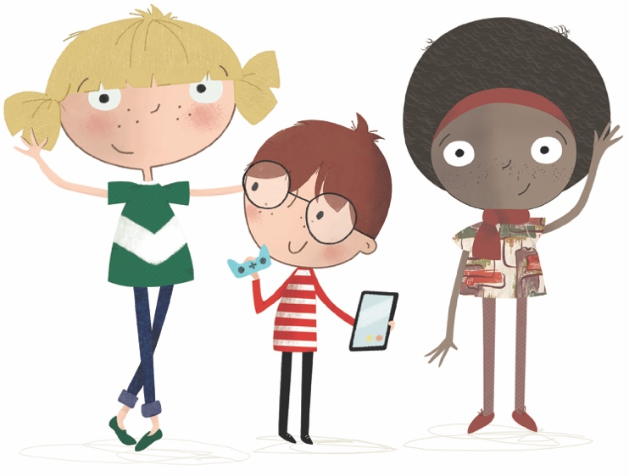
thinkuknow.org.au

